# Azure Cloud App setup and Deployment

## Registering on Azure for Students

You will need a phone that can receive SMS messages and your college email/password before following these steps.  
At **no** point in any of these steps should you need to enter credit or debit card details. If you are asked to, you've taken a wrong turn somewhere.

1. Open an "InPrivate" or "Incognito" browser session. This is important as you want to avoid any cookies from your other accounts
2. Navigate to **Azure for Students** (*not* Azure for Students *Starter*):
   1. If based in Ireland at time of signup: <https://azure.microsoft.com/en-ie/free/students/>
3. Click *Activate Now*
4. Sign in to your account – you **must** use your college account
5. Fill in the 'About You' section, use college email for the "Email address for important notifications"
6. Verify by phone - "Text me" will send you a code your phone
7. Accept the User Agreement and click **Sign up**
8. Microsoft Azure dashboard should appear

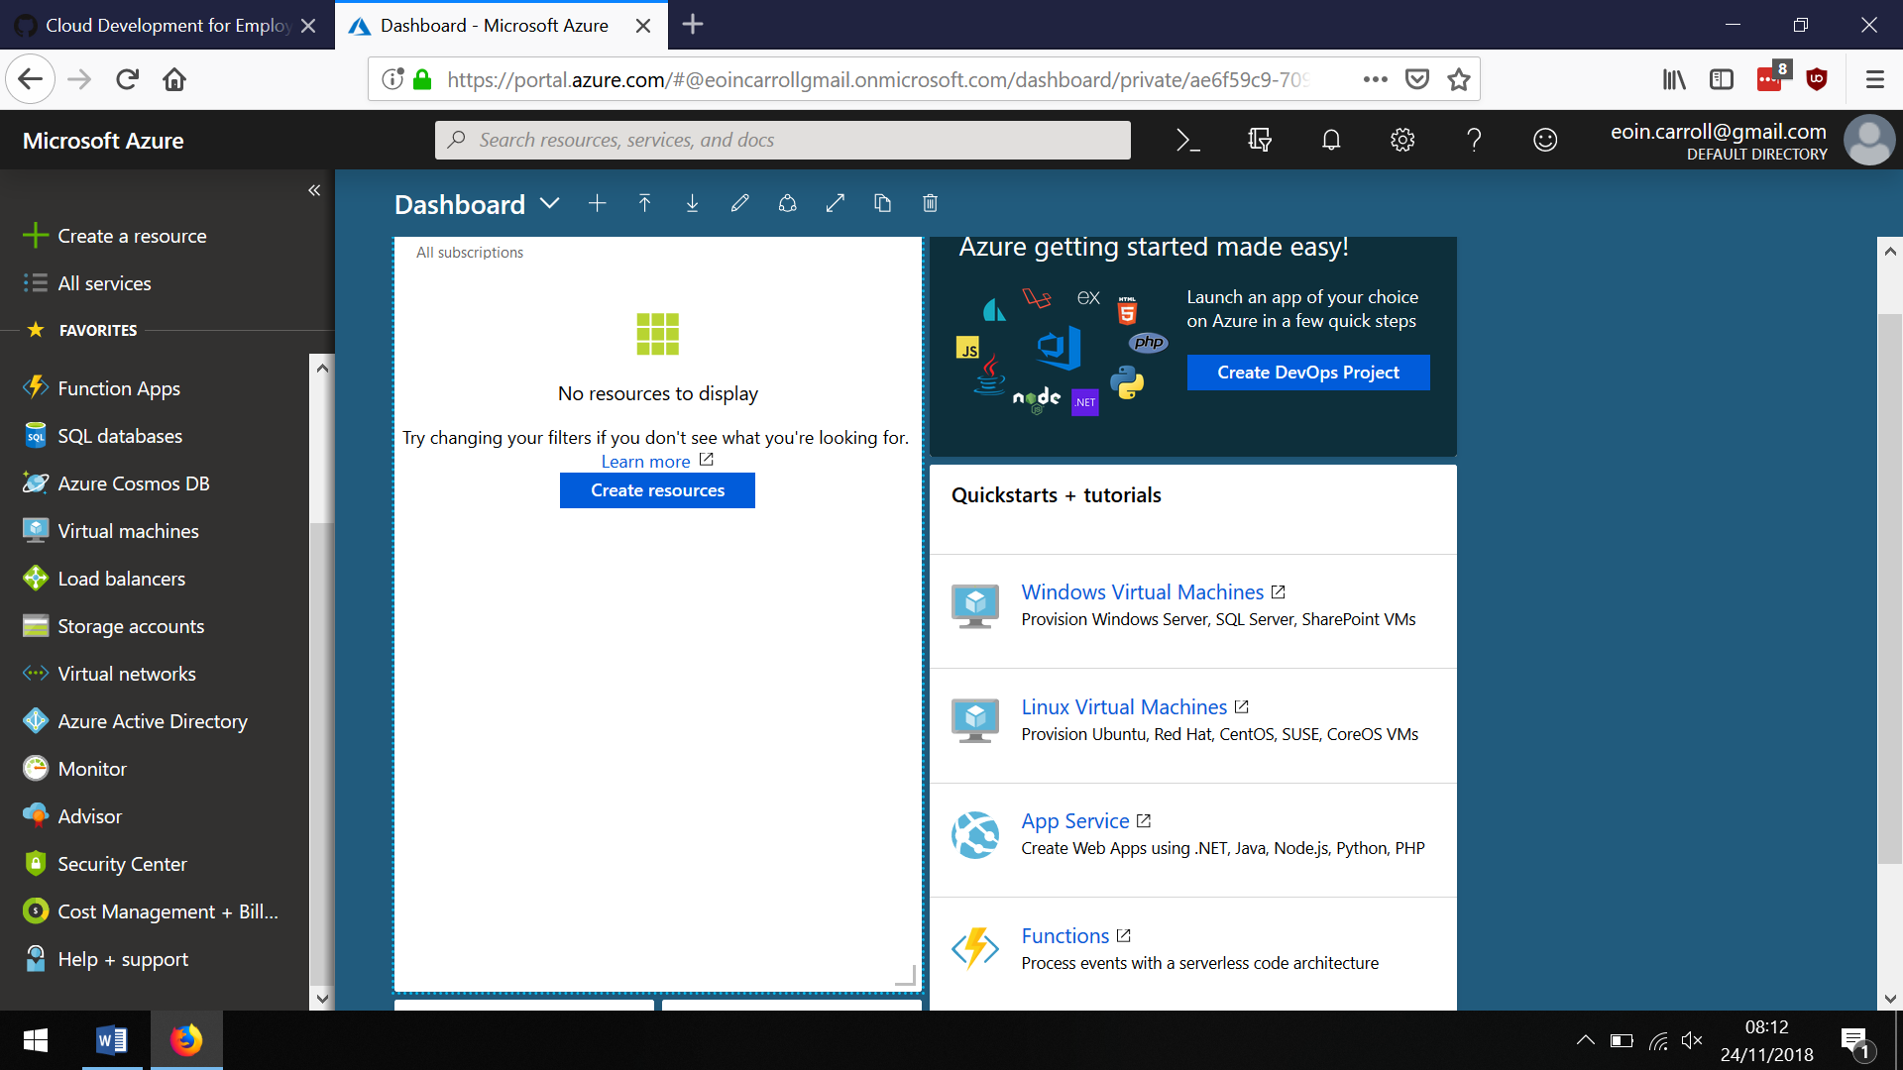

## Configuring our Azure account for our web app.

1. Log in to the Azure Portal, ensure you use your college email
2. Create a resource
3. Search for and select Web App
   1. Give it a unique name
   2. Ensure subscription is **Azure for Students**
   3. Create a new resource group (use a similar name so you know they are related)
   4. Select **Windows** (not because I work in Microsoft, but because you want to use Java/Jetty, and the Linux and Docker containers won't let you configure that as easily!)
   5. Select a new App Service Plan (give it a name, select **North Europe** as the location and Pricing tier of **F1 Free**)
   6. Leave **Application Insights** *off*
   7. Pin to Dashboard and **Create**

## Configure the Azure App Service for Java and Jetty

1. In your app dashboard, go to **Settings** - **Application Settings**
   1. Java version - **Java 8**
   2. Java minor version - **Newest**
   3. Java web container - **Newest Jetty 9.3**

## Code your Webapp

1. Create your Webapp as normal, in this case we'll use a generic Vaadin application quickstart webapp
2. Maven new project: **mvn archetype:generate -DarchetypeArtifactId="vaadin-archetype-application" -DarchetypeGroupId="com.vaadin"**
3. 'groupId': **ie.examples**
4. 'artifactId': **VaadinGenericApp**
5. Build your app with Maven Install, test it with Jetty on localhost
6. Find the final **target/appname.war** file and rename it to **ROOT.war** (we could automate that but no harm in learning what's happening behind the scenes)
7. On the command line, this works:

cd .\target\

ren .\VaadinGenericApp-1.0-SNAPSHOT.war ROOT.war

1. (On Windows) If you want to open a File Explorer here, type **explorer .** The full stop is important, it means 'this folder'!

## (Re)Deploy your app

There are a few different ways to deploy, but a simple way is to **FTP** (File Transfer Protocol) your app to the webapps folder on your App Service. First, we need to tell your app that you might be FTP'ing to it

1. Open the app in the Azure portal
2. In **Deployment** - **Deployment Credentials** add an FTP username and password (save and remember them)
3. In Overview, copy **FTP hostname**

If you want to use a dedicated FTP client you can, if you have a recent version of Windows, it's built into Windows File Explorer:

1. **Windows Key + E** opens File Explorer
2. Paste **FTP hostname** into the address bar (in my case it was **ftp://waws-prod-db3-095.ftp.azurewebsites.windows.net**)
3. It should prompt you for the FTP username and password you set above
4. Navigate to **site - wwwroot - webapps** and drop/paste/copy **ROOT.war** into that folder (you renamed your .war file in the previous section)
5. Wait for it to finish copying and close the window

Now you should be able to visit the app name (something.azurewebsites.net) and see your app running. If you don't immediately, give it a few seconds to reload...